1. What exactly is []?

[] is the presentation of list

2. In a list of values stored in a variable called spam, how would you assign the value 'hello' as the third value? (Assume [2, 4, 6, 8, 10] are in spam.)

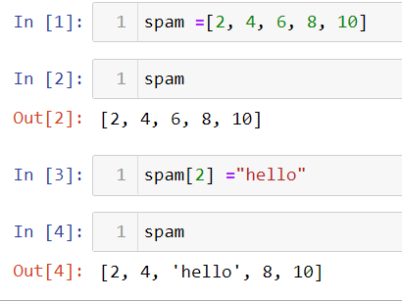

Let's pretend the spam includes the list ['a', 'b', 'c', 'd'] for the next three queries.

3. What is the value of spam[int(int('3' \* 2) / 11)]?

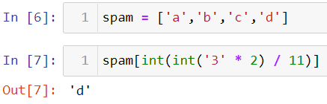

4. What is the value of spam[-1]?

‘d’

5. What is the value of spam[:2]?

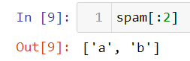

Let's pretend bacon has the list [3.14, 'cat,' 11, 'cat,' True] for the next three questions.

6. What is the value of bacon.index('cat')?

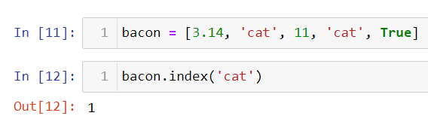

7. How does bacon.append(99) change the look of the list value in bacon?

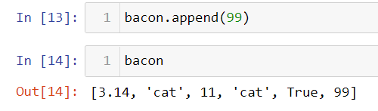

8. How does bacon.remove('cat') change the look of the list in bacon?

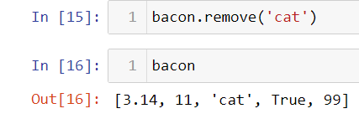

9. What are the list concatenation and list replication operators?

Concatenation is done by + operator. Concatenation is supported by sequence data types(string, list, tuple). Concatenation is done between the same data types only.

The \* operator replicates the elements in the list.

10. What is difference between the list methods append() and insert()?

append() - The append method adds a new item to the end of a list

insert() – The insert method allows you to can create a new entry exactly in the position you want

11. What are the two methods for removing items from a list?

remove()

pop()

12. Describe how list values and string values are identical.

Both strings and lists have lengths: a string's length is the number of characters in the string; a list's length is the number of items in the list

You can access individual characters in a string, or items in a list, using square-bracket indexing[]

13. What's the difference between tuples and lists?

Tuples

* ()
* Immutable
* Elements can be accessed better
* Unexpected errors and changes rarely occur in lists.

Lists

* []
* Mutable
* Operations like insertion and deletion can be better performed.
* Unexpected errors and changes can easily occur in lists.

14. How do you type a tuple value that only contains the integer 42?

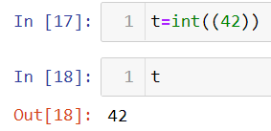

15. How do you get a list value's tuple form? How do you get a tuple value's list form?

Use list() to get list value from tuple

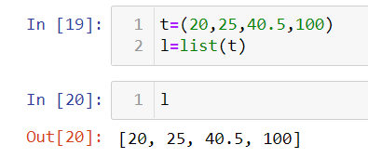

Use tuple() to get tuple value from list

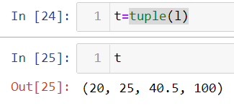

16. Variables that "contain" list values are not necessarily lists themselves. Instead, what do they contain?

Variables will contain references to list values rather than list values themselves. But for strings and integer values, variables simply contain the string or integer value

17. How do you distinguish between copy.copy() and copy.deepcopy()?

A shallow copy constructs a new compound object and then (to the extent possible) inserts references into it to the objects found in the original.

When a deep copy in Python creates a new object, it inserts into the new object copies of the objects in the original object. In other words, it copies an object into another.